Devansh Shah

1914078

B1

# Idea Introduction

* Background

The youth in India are on a constant lookout to search for entertainment places and new experiences. Some prefer giving their time and/or money to go to outdoor places whereas some prefer calling people home. This creates a demand for new entertaining places but with the limited area and high rent in metropolitan areas, investing in an entertainment outdoors like in malls, clubs becomes expensive. Moreover these places have high influx only during holidays and weekends causing a huge open market to capitalize on entertainment on week days. To spend quality time with family and friends, the usual trend is to go to some restaurants or order in which over a longer span gets repetitive and expensive causing boredom and loss of interest. Let’s say there was a way by which rather than wasting time on travel, booking and going heavy on pockets, there was a way to bring the entertainment to you. House parties is one of the most growing trend where infrastructure is one’s own but can have the same party feeling at the leisure of your home. Neither does this mean partying at home with loud music does not have it’s own set of problems nor that a house party means to have dance showdown with music but rather encases playing cards, board games, video games and much more.

Idea-

We propose to build a platform to connect the young users who prefer a house party but lack all the fun things which might be costly to invest in just for a night. This platform will not only provide card, board and video games on rent but also will be one stop house party requirements and set up app. The users of this platform can choose on the type of house party they want with their friends and family by entering data on the size of their home, number of people and activities they want to engage in for the night. This idea will revolutionalize the house party culture and for a mere fee which is way less than owning all these things which might not be used for more than a night, we provide users easy access to such entertainment. The users will place the order after selecting things they want just like adding items to cart and once payment is confirmed, these items will be rented for the specific hours( let’s say 8 hours) with a complete pick up and drop service making this an independent service with the power onto the user’s fingertips.

They would just need to create an account and use it like any other e-commerce application which the world is already use to. Moreover this idea can expand from small scale games to entire party planning application at low cost piquing the interest of the young users who would be satisfied after having a total redefined experience of partying at home.

**Idea validation using Google advanced search:**

**Query 1** : house party "party at home app"

**Results**

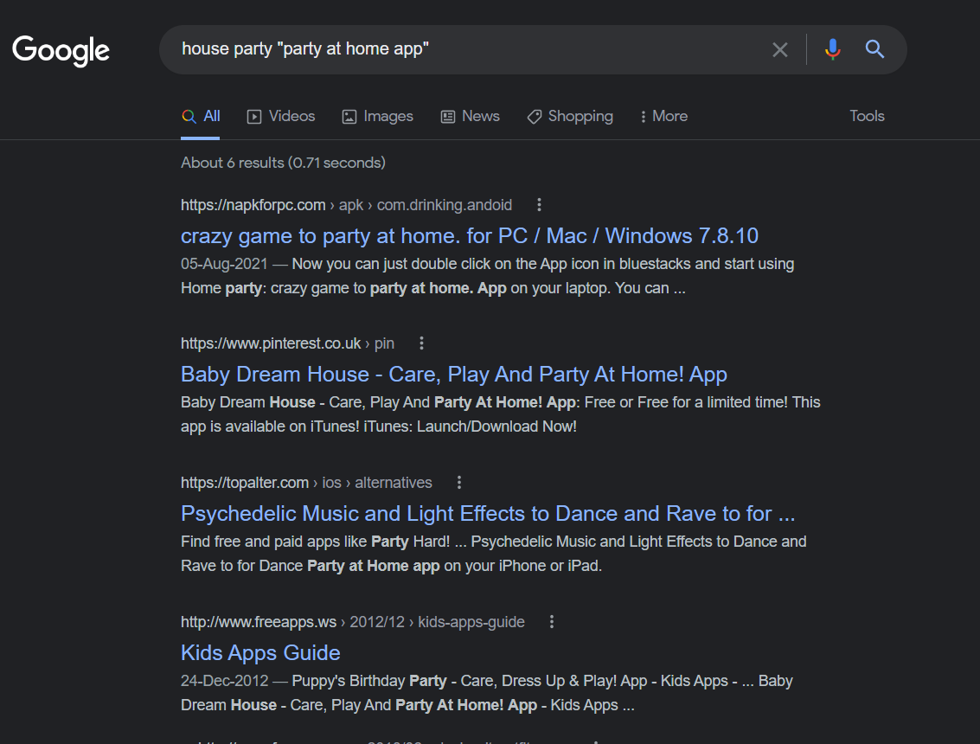

**Remarks:**

A web based application for partying at home does not exist but ideas for what to do if you own the games do.

**Query 2** : web app party at home app OR app for house party planning

**Result**:

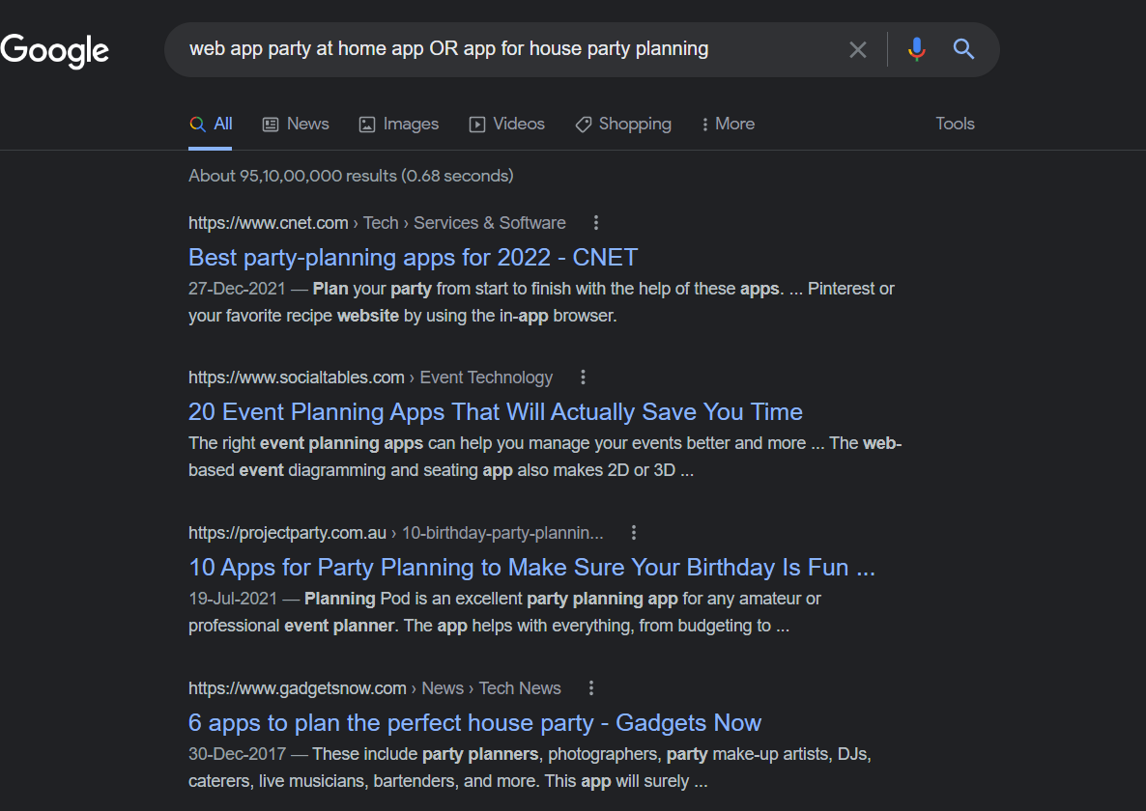

**Remark**:

Several party planning apps exist similar to my idea but none match the execution required for partying at home without any investment in the several widespread products.

**Query 3** : renting apps "games"

**Results**

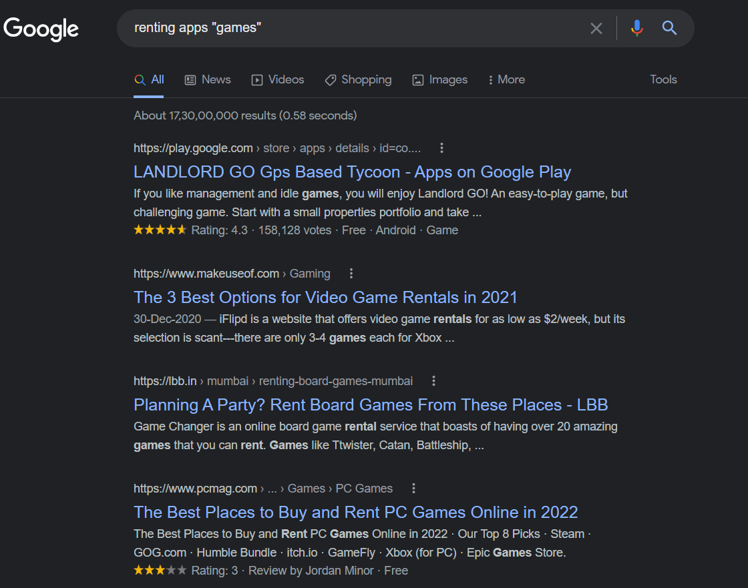

**Remark**: 95% of apps rent PC or PS4/5 games but they are at small case without their own application to support the idea. Very few of them give at home delivery experience which is further based on the distance from the outlet. This opens up market further to disrupt it and redefine the entire process.

**Query 4**: allintext: party at home statistics

**Result**:

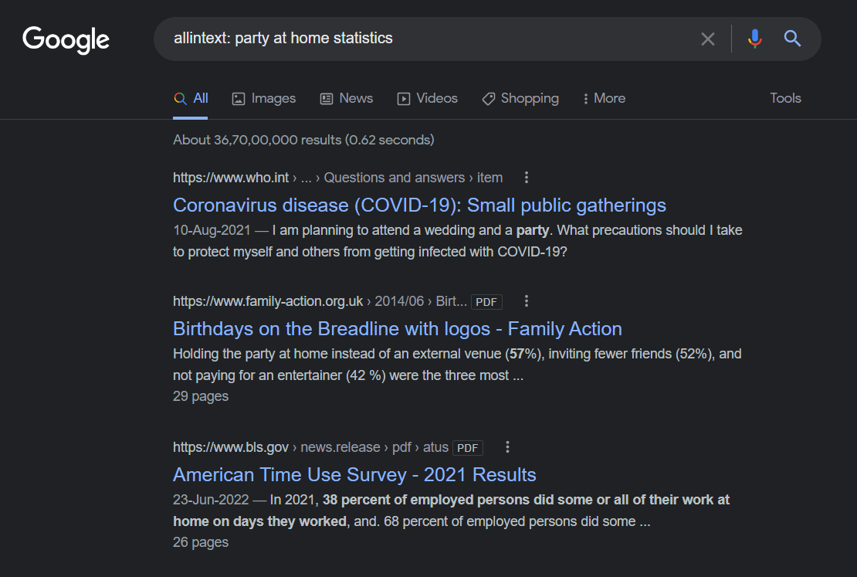

**Remark**:

38 percent of employed persons did some or all of their work at home on days they worked, and. 68 percent of employed persons did some kind of fun activity in their weekends but weekdays lacks opportunities of fun. This reinforces our faith in the idea that personalized recommendations for partying at home based on user preferences are important.

**Conclusion:**

Our idea would be worth pursuing because there aren’t any one stop party planning apps which rent out games, other accessories and silent dj options based on the size and several other factors giving the user as much freedom to plan getogathers at their own place at low setup cost. Neither do the other apps provide one centralized platform like an e-commerce application to smoothen this process with delivery and pick up before and after the event. This has potential to disrupt the entertainment industry.